**IBM Cloud and CLI**

|  |  |
| --- | --- |
| Team ID | PNT2022TMID23716 |
| Project Name | Smart Fashion Recommender Application |

Step -1: Get into the IBM Cloud by container registry and install the IBM Cloud CLI

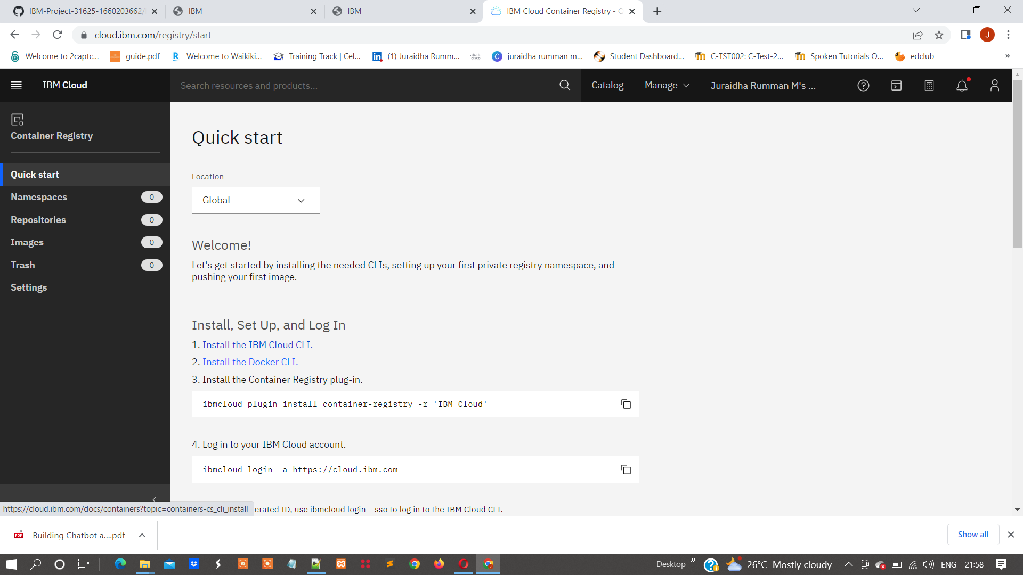

Step-2: Install the windows powerShell and install the IBM Cloud CLI

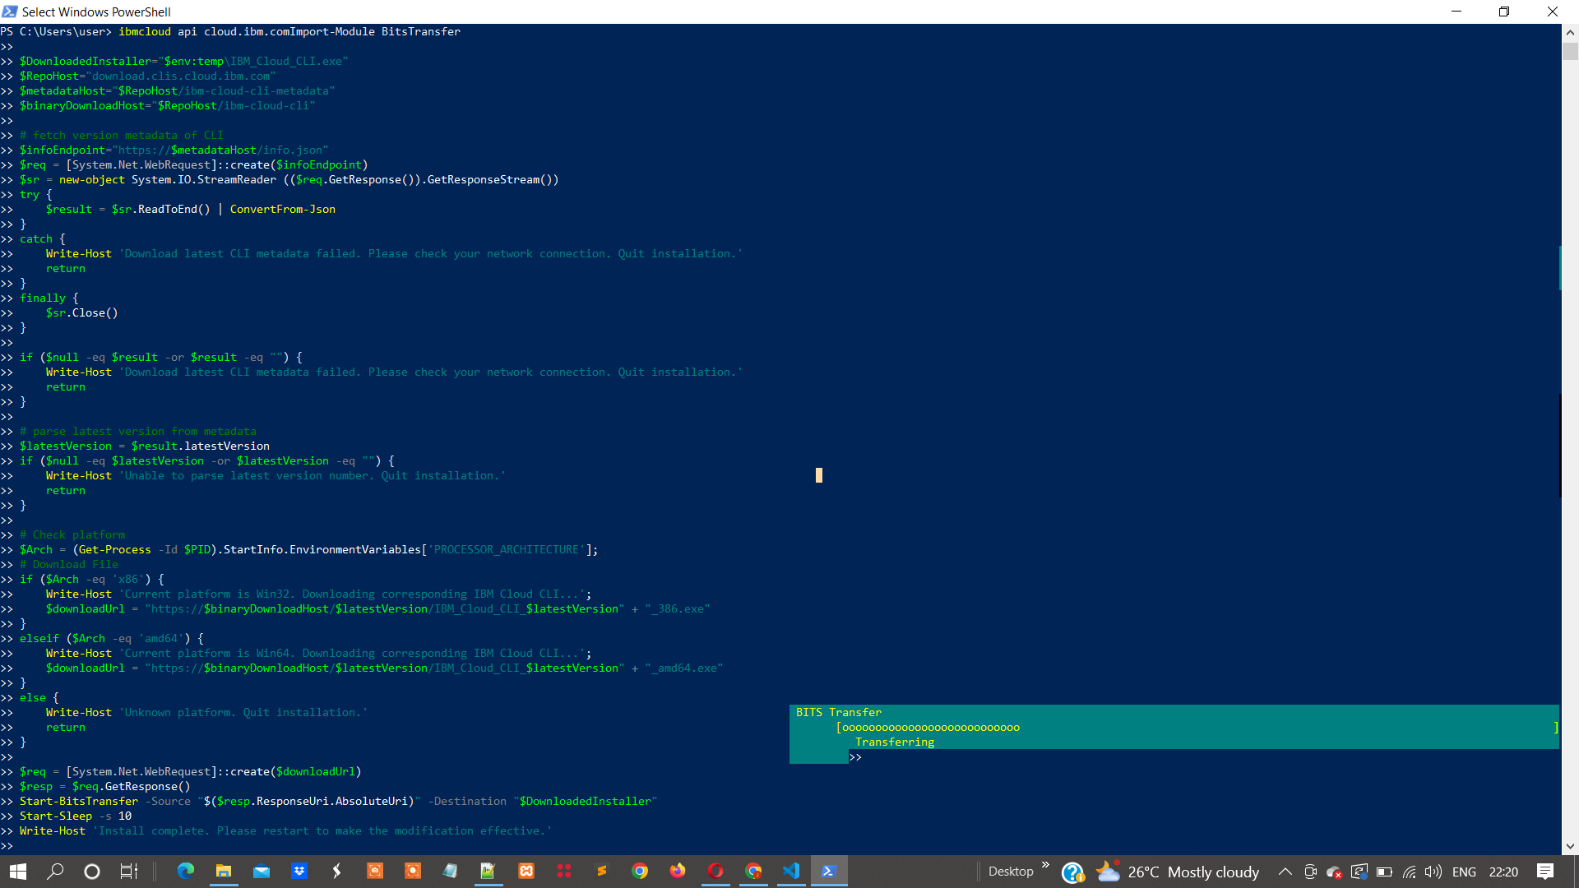

Step-3: After the execution of commands the IBM Cloud CLI is installed Successfully

